**A PROJECT REPORT ON**

**“SUDOKU SAGA”**

**Submitted to the Mangalore University**

**in partial fulfillment of the requirement**

**for the award of the Degree of**

**BACHELOR OF COMPUTER APPLICATION**

**Submitted by**

**SAMRDH**

**Register Number: U05SD21S0037**

**Under the valuable guidance of**

**MR. ARUN F. SEQUEIRA**



**SHRI DHARMASTHALA MANJUNATESHWARA**

**COLLEGE OF BUSINESS MANAGEMENT**

**Mangaluru – 575003**

**2023–2024**

**Shri Dharmasthala Manjunatheshwara**

**College of Business Management,**

**Mangaluru – 575003**

**(Affiliated to Mangalore University)**



**CERTIFICATE**

This is to certify that the project report entitles **“SAMRDH”** is an authenticated record of the project work carried out by **SAMRDH** bearing Register Number **U05SD21S0037** in partial fulfillment of the requirement for the award of **Bachelor’s Degree in Computer Application** of Mangalore University under the guidance and supervision during the year 2023-2024.

**Forwarded to Principal for Approval**

Place: Mangaluru

Date: June 01, 2024 (Mr. Arun F. Sequeira)

Project Guide

**Approved and Forwarded to Mangalore University**

Place: Mangaluru

Date: June 01, 2024 (Prof. Aruna P. Kamath)

Principal

**Signature of the Examiners:**

**1………………………………… 2……………………………….**

**DECLARATION**

We hereby declare that the project report titled as **“SUDOKU SAGA”** has been prepared by us during the year 2023–2024 under the valuable guidance and supervision of **Mr. Arun F. Sequeira,** Assistant Professor and project guide, SDM College of Business Management, Mangaluru, in partial fulfilment of the requirement for the award of degree in Bachelor of Computer Application from Mangalore University for the academic year 2023-2024.

We also declare that this project is the result of our own effort and has not been submitted to any other University for the award of any degree or diploma.

Place: Mangaluru ………………………..

Date: June 01, 2024 SAMRDH

Reg. No.: U05SD21S0037

**ACKNOWLEDGEMENT**

Whatever we are able to put forward in terms of outwork, is only due to few people from whom we have learnt. Thus, it is a great pleasure in mentioning their names.

Working on the live project was very interesting and really enhanced our knowledge.

We would like to express our sincere gratitude to our beloved principal **Prof. Aruna P. Kamath** without whose permission we would not be able to do our project and for taking keen interest for the students of BCA in providing useful guidelines and giving all the necessary facilities.

We extend thanks to our guide **Mr. Arun F. Sequeira**, Assistant Professor of Computer Application Department for his valuable guidance and constant encouragement, which helped us in successfully completing our project.

Finally, we extend thanks to our parents and friends who were directly or indirectly involved in the completion of our project.

Place: Mangaluru …….…………………..

Date: June 01, 2024 SAMRDH

Reg. No.: U05SD21S0037

# Table of Contents

|  |  |  |
| --- | --- | --- |
| **Chapter no.** | **Chapter title** | **Page no** |
| **1.** | **Project Synopsis** |  |
| **2.** | **Survey of Technologies** |  |
| **3.** | **Table Design and ER diagram** |  |
| **4.** | **Module Description and Screenshots** |  |
| **5.** | **Conclusion, Limitations and Future Scope** |  |
| **6.** | **References** |  |

# Chapter-1

## PROJECT SYNOPSIS

1. **Title of the Project**

Suduko Saga: The title “Sudoku Saga” effectively captures the essence of your project, suggesting a journey through the challenges and levels of Sudoku.

1. **Statement of the Problem**

Despite the popularity of Sudoku as a cognitive exercise, many digital platforms present barriers that can deter users from engaging with the game. The requirement for account creation and registration is one such barrier, often seen as a hassle or a privacy concern. Furthermore, the lack of adaptive difficulty levels and comprehensive strategic guidance can leave players, especially beginners, feeling unsupported and overwhelmed.

**Core Challenges:**

Accessibility: Mandatory user registration processes can be off-putting and discourage potential players from engaging with the game.

Adaptability: A one-size-fits-all approach to difficulty levels does not cater to the diverse skill set of Sudoku players, from novices to experts.

Educational Support: Insufficient guidance on Sudoku strategies and techniques can hinder a player’s development and enjoyment of the game.

**Project Feasibility:**

The project is technologically feasible, with current web development technologies capable of supporting the envisioned features.

The identified obstacles are addressable through user-centric design and functionality.

**Strengths and Opportunities:**

The direct login feature addresses the accessibility challenge, allowing instant gameplay.

The inclusion of multiple difficulty levels ensures adaptability, catering to a wide range of users.

The help section and solver tool provide educational support, enhancing the user’s learning experience.

**Weaknesses and Threats:**

The absence of user registration may pose challenges in tracking progress and personalizing the experience.

Balancing the solver feature to provide help without undermining the puzzle’s challenge will require careful consideration.

**III. Purpose**

The purpose of “Sudoku Saga” is multifaceted, rooted in the desire to enhance the Sudoku experience by leveraging modern technology to address specific user needs. The project was chosen not for its ease but for the significant challenges it presents in terms of accessibility, adaptability, and educational value.

**Why This Problem?**

Cognitive Stimulation: Sudoku is recognized for its ability to stimulate cognitive functions, and this project aims to make such benefits widely accessible.

Technological Simplification: By removing the registration barrier, the project simplifies the technology adoption process for users.

User Engagement: The project seeks to engage a broader audience by providing a platform that is easy to use and educational.

**Project Goals:**

Immediate Access: To offer a platform where users can engage with Sudoku puzzles without the need for prior registration.

Learning and Development: To provide resources that help users learn and apply various Sudoku strategies, enhancing their problem-solving skills. Inclusive Design: To create a platform that is welcoming to users of all skill levels, from beginners to advanced players.

**Contribution to the Business Community:**

Increased User Base: By simplifying access to the game, the project aims to attract a larger user base.

Educational Tool: The platform serves as an educational tool, potentially opening up avenues for collaboration with educational institutions.

**Future Work Scope:**

Feature Expansion: Future enhancements may include personalized progress tracking and community features, despite the lack of registration.

Algorithmic Improvements: Ongoing development to refine the solver algorithm, ensuring it remains a helpful tool without detracting from the challenge of the game.

**IV. Objective and Scope**

The objective of “Sudoku Saga” is to revolutionize the way Sudoku is played and learned online. The project aims to create an inclusive, educational, and accessible platform that caters to Sudoku enthusiasts of all levels.

**Primary Objectives:**

Enhance Accessibility: To eliminate the need for registration, providing users with immediate access to Sudoku puzzles.

Cater to All Skill Levels: To offer a range of difficulty levels, ensuring that the platform is engaging for beginners and challenging for advanced players. Promote Cognitive Development: To provide educational resources that help users learn and improve their Sudoku skills.

**Scope of the Project**: “Sudoku Saga” will encompass the following features: Direct Login: Users can start playing immediately without the need to create an account.

Multiple Difficulty Levels: A variety of puzzles will be available, ranging from easy to expert.

Help Options: A dedicated section will guide users on how to play Sudoku and offer strategies for solving puzzles.

Solver Tool: A feature where users can input clues and receive assistance in solving puzzles.

**Future Enhancements:**

Progress Tracking: Implementing a system to track user progress and provide personalized recommendations, even without traditional user accounts.

Community Features: Introducing leaderboards, challenges, and social sharing to foster a community of Sudoku players.

**V. Process Description**

**“Sudoku Saga”** is designed to offer a streamlined and intuitive user experience, from the moment a player enters the platform to the completion of a puzzle. The process is as follows:

**Direct Access:** Users are welcomed to the platform without any registration hurdles. They can immediately access the game interface.

**Puzzle Selection:** Players can choose from a variety of Sudoku puzzles categorized by difficulty levels—beginner, intermediate, advanced, and expert.

**Gameplay:** Once a puzzle is selected, users can begin solving it using the intuitive interface, which includes features like pencil marks and undo options.

**Help and Strategies**: If a player needs assistance, the help option provides a link to resources that explain the rules of Sudoku and offer strategies for solving puzzles.

**Solver Tool:** For those who are stuck or wish to verify their solutions, the solver tool allows users to input clues and receive guidance or the complete solution.

**Continuous Play**: After completing a puzzle, users can choose to play another puzzle, try the same puzzle at a different difficulty level, or explore the help section to improve their skills.

**Technical Workflow:**

The platform utilizes modern web technologies to ensure a responsive and secure experience across various devices.

An algorithmic solver is integrated to assist with puzzle-solving without compromising the challenge.

User interactions are designed to be simple and efficient, minimizing the learning curve and maximizing engagement.

By detailing this process, “Sudoku Saga” demonstrates its commitment to providing an enriching and hassle-free Sudoku experience that caters to the needs of all users, from casual playersto serious puzzle enthusiasts.

**Extra games:**

This platform provides extra other games for the user if they gets bored or want to experience something new. Snake Game ,tic-tac-toe , and are the extra available games .

**VI. Resources**

**Hardware requirements:**

Processor:intel core i3 or above

RAM:Minimun 2GB ram

Network:A stable internet connection with a minimum speed of 5Mbps

**Software requirements:**

Operating system: Windows 10/11

Coding language: JavaScript

Browser: Mozilla Firefox/Google chrome/Internet explorer

IDE: VSCode

# Chapter-2

## SURVEY OF TECHNOLOGIES

“Sudoku Saga” The project integrates a blend of programming languages, frameworks, and tools to create a seamless and interactive gaming experience.

**Frontend Technologies:**

**HTML5:** The backbone of the user interface, providing the structure for the web pages.

**CSS3:** Used for styling and presenting the game with a visually appealing layout.

**JavaScript:** Ensures dynamic interaction and responsiveness within the game.

**Backend Technologies:**

As “Sudoku Saga” does not involve user registration or data storage, backend technologies are primarily focused on the solver algorithm and game logic. **Solver Algorithm:**

Algorithm Design: A sophisticated algorithm that can efficiently solve Sudoku puzzles of varying difficulties.

**Optimization:** Techniques to optimize the solver for speed and accuracy.

Additional Tools:

**YouTube API:** Integration that allows users to access helpful Sudoku tutorials directly from the game interface.

**Help Feature:** A custom-built help system that guides users through the game and provides tips for solving puzzles.

**Hosting and Deployment:**

**Web Hosting Service**: A reliable platform that hosts the web application, ensuring it is accessible to users worldwide.

**Continuous Integration/Continuous Deployment (CI/CD): Automated** pipelines that facilitate the deployment of updates and new features. **Conclusion:** The technology stack of “Sudoku Saga” is carefully chosen to ensure that the game is not only fun and challenging but also robust and scalable. It reflects a commitment to providing a high-quality gaming experience that is both educational and enjoyable.

# Chapter-3

## TABLE DESIGN AND ER DIAGRAM

“Sudoku Saga” is designed to be a straightforward and user-friendly application that does not require data persistence or user account management. Consequently, the project architecture is simplified, and there is no need for a database, which eliminates the necessity for table design and ER diagrams.

The data flow in “Sudoku Saga” is transient and only exists during the user’s interaction with the game. Puzzles are generated and solved in real-time, and the results are not stored post-session. This approach ensures privacy and ease of access, as users can immediately engage with the game without the hurdles of account creation and data management

# Chapter-4

## MODULE DESCRIPTION AND SCREENSHOTS

“Sudoku Saga” is composed of several key modules that work together to provide a seamless and enjoyable gaming experience. Below are the descriptions of each module:

1. **Puzzle Generator Module:**

Function: Generates new Sudoku puzzles for the user to solve.

Features: Offers various difficulty levels, ensuring a suitable challenge for all players.

1. **Solver Module:**

Function: Provides solutions to Sudoku puzzles through backtracking when the user requests assistance.

Features: Includes a step-by-step guide to solving the puzzle or an instant solution reveal.

1. **User Interface (UI) Module:**

Function: Manages the presentation and interaction layer of the application. Features: Ensures a responsive and intuitive layout across different devices and screen sizes.

1. **Help and Tutorial Module:**

Function: Assists users with how to play Sudoku and offers strategies for solving puzzles.

Features: Integrates with YouTube tutorials and provides in-game hints.

1. **Game Logic Module:**

Function: Handles the rules and mechanics of Sudoku gameplay.

Features: Validates user input, tracks puzzle completion, and manages game states.

1. **Difficulty Management Module:**

Function: Adjusts the complexity of the puzzles based on the selected difficulty level.

Features: Dynamically alters puzzle parameters to increase or decrease the challenge.

Each module is designed with a focus on user experience and performance, ensuring that “Sudoku Saga” is not only fun to play but also a tool for improving cognitive abilities.

**Home page**

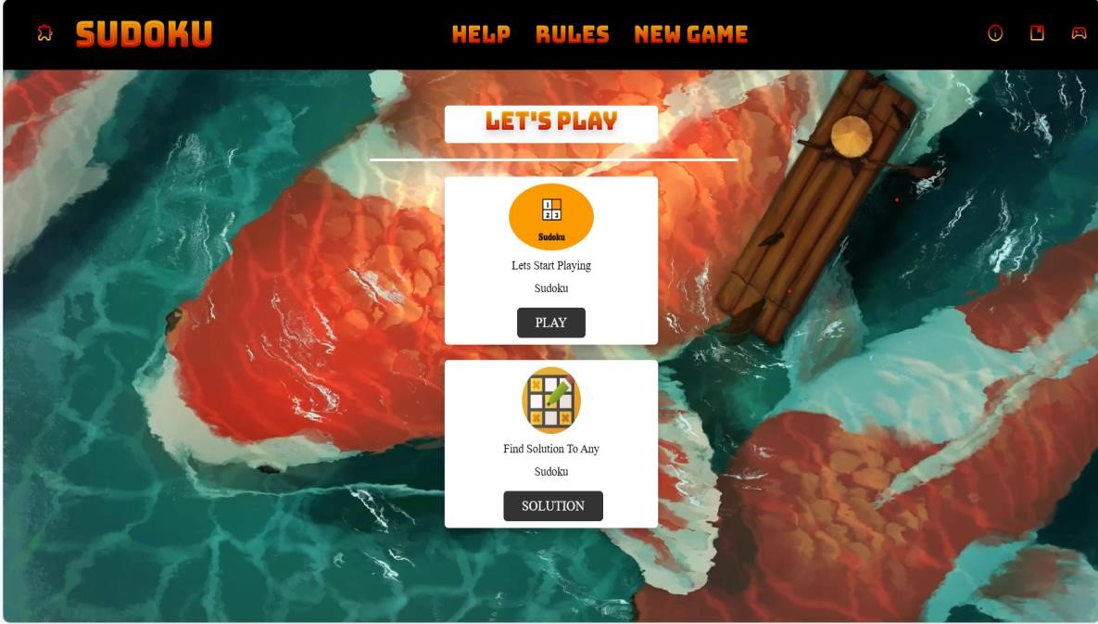

**Game page**

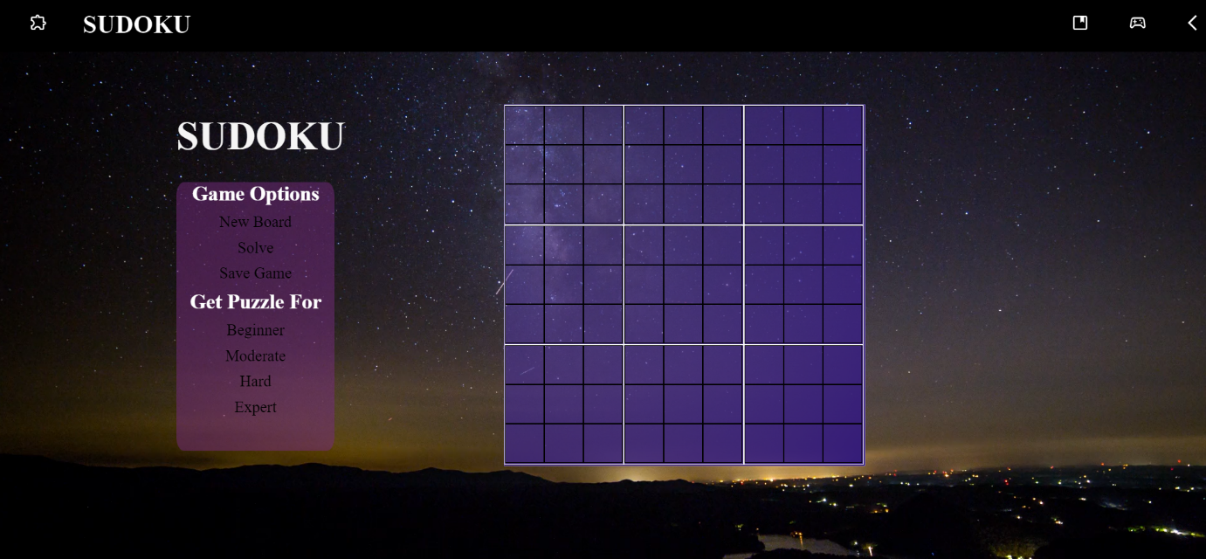

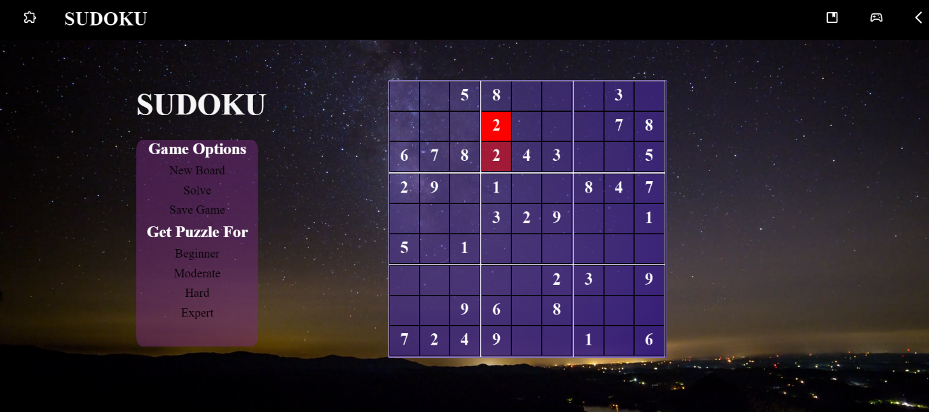

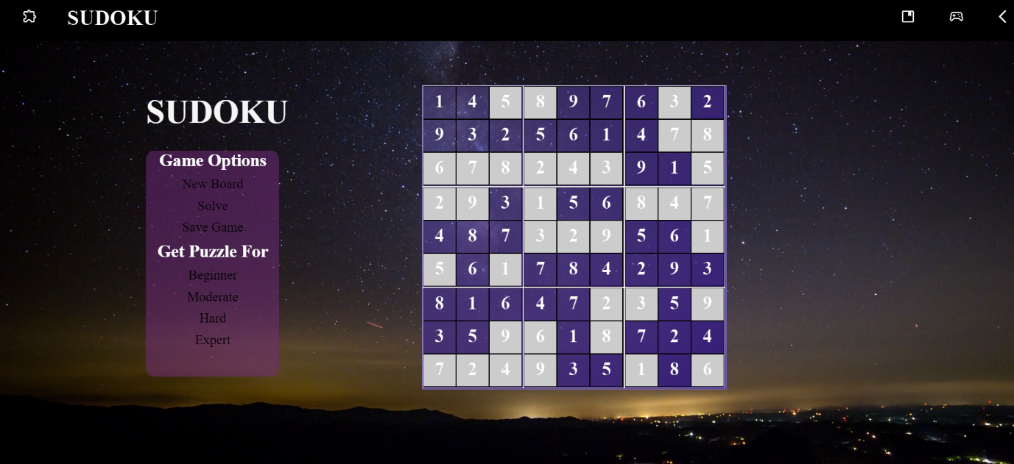

**Solver page**





**Solution**

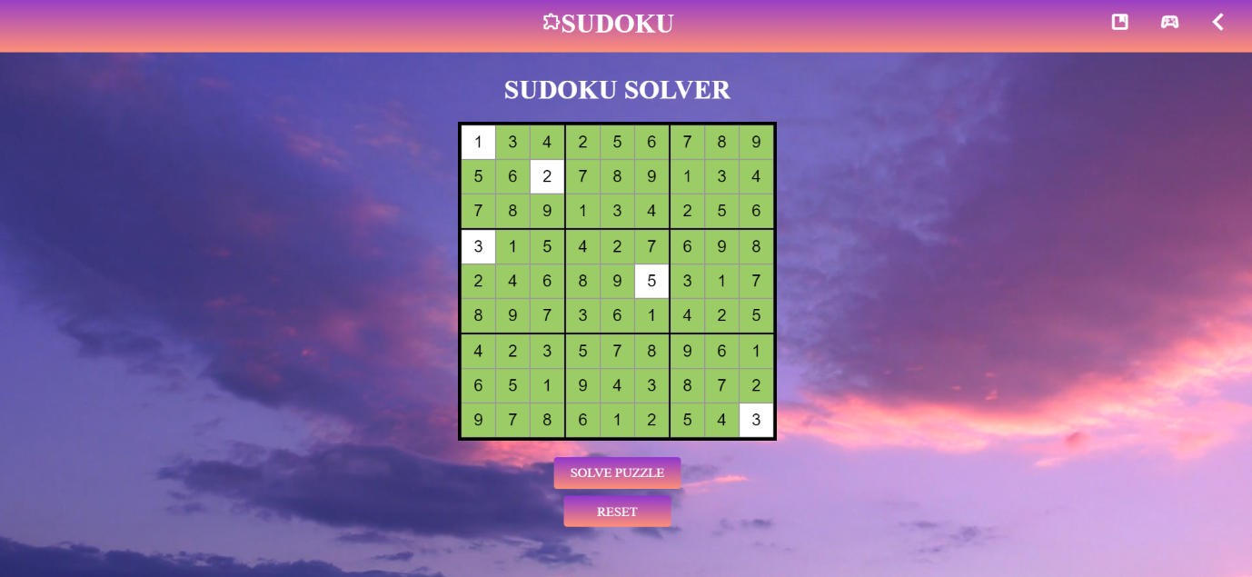

Extra 4 games :

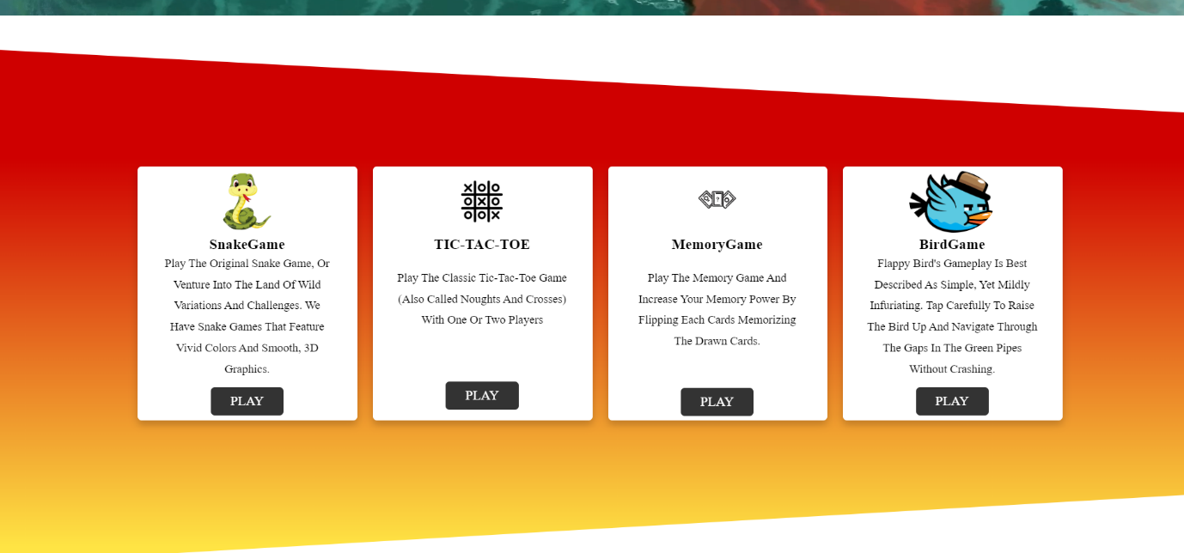

# CHAPTER 5

## CONCLUSION, LIMITATIONS AND FUTURE SCOPE

**Conclusion**

In the journey through the technological landscape of “Sudoku Saga,” we’ve explored the intricacies of creating a puzzle platform that transcends mere entertainment. Let’s recap the key takeaways:

Web Technologies: The choice of React.js for the front end ensures a dynamic and responsive interface. HTML5 and CSS3 provide the backbone for structuring and styling the game.

Solver Algorithms: Our Sudoku solver algorithm, based on constraint satisfaction principles and heuristic search, empowers users to find solutions or receive hints.

User Experience (UX) Design: Simplicity, intuitiveness, and responsiveness are at the core of our design. Users can dive into puzzles without friction, aided by an uncluttered interface.

Performance Optimization: We’ve minimized load times and resource usage, ensuring smooth gameplay even on slower connections.

Security Measures: The absence of a database means no user data is stored, enhancing privacy. Secure coding practices fortify the platform against vulnerabilities.

**Limitations and Future Scope** Limitations:

No Personalization: Without user accounts, we miss out on personalized experiences and progress tracking.

Ephemeral Sessions: Game sessions are transient; users can’t pause and resume puzzles.

Community Interaction: Leaderboards and social features are currently unavailable.

Future Scope:

Progress Tracking: Implement local storage for session persistence.

Community Features: Explore one-time nicknames or avatars for light community interaction.

Puzzle Variations: Add new Sudoku variants to keep users engaged.

Adaptive Learning: AI-driven puzzles tailored to user skill levels. Mobile App: Extend the experience to mobile devices.

# CHAPTER 6

**REFERENCES**

<https://youtu.be/PlbupGCBV6w?si=NExWbry-mTrdfNAI><https://www.w3schools.com/jsref/jsref_reference.asp>

**JavaScript:** The Complete Reference